UV DYE
11.004_11.005_11.060

DESCRIPTION
Thanks to UV tracers, it is very quick and easy to identify refrigerant gas leaks in A/C and refrigeration systems. Our UV dye doesn’t contain any kind of solvent so it haven’t any kind of negative effect in the systems and it doesn’t damage the equipments.
Compliant with regulations SAE J2297 and SAE J2298.

Compatible with: R22, R134a, R404, R407, R410

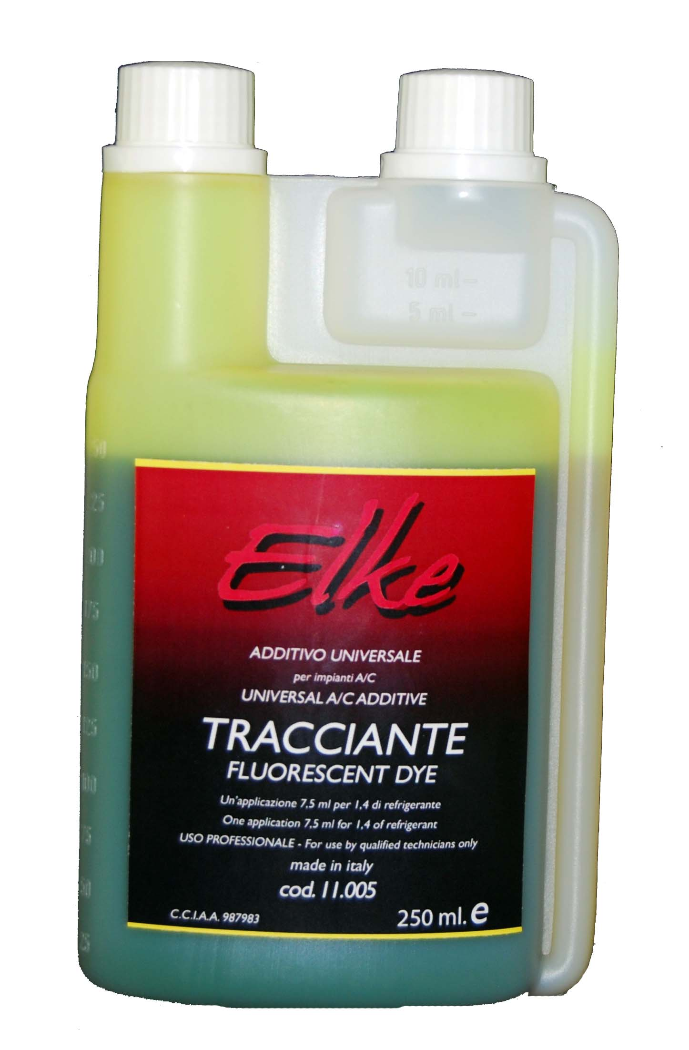

INSTRUCTIONS FOR USE

- Put the UV dye in the injector (7,5 ml for 1,5 Kg of refrigerant gas). Before to connect the injector, let the air inside the hose out.
- Connect the injector to the low pressure side of the system and inject the dye.
- Disconnect the injector and remove the dye residuals.
- Start the A/C system and let it work for 30 minutes.
- After worn the protective glasses, use an UV lamp to inspect the parts where the leak could be. The spots in correspondence of the leaks will appear luminescent.
- When the leak is repaired, clean up the interested area with the appropriate detergent and then repeat steps 1 to 3.
SAFETY INFORMATION

Wear gloves and protective clothing. Avoid contact, ingestion and inhalation. While working do not eat or drink. In case of skin contact, wash with water and soap. In case of eyes contact, wash with water for at least 10 minutes. In case of inhalation, aerate the room and take injured person to an aerated room. In case of ingestion, induce vomiting and seek medical advice. Keep out of reach of children. Professional use only.

